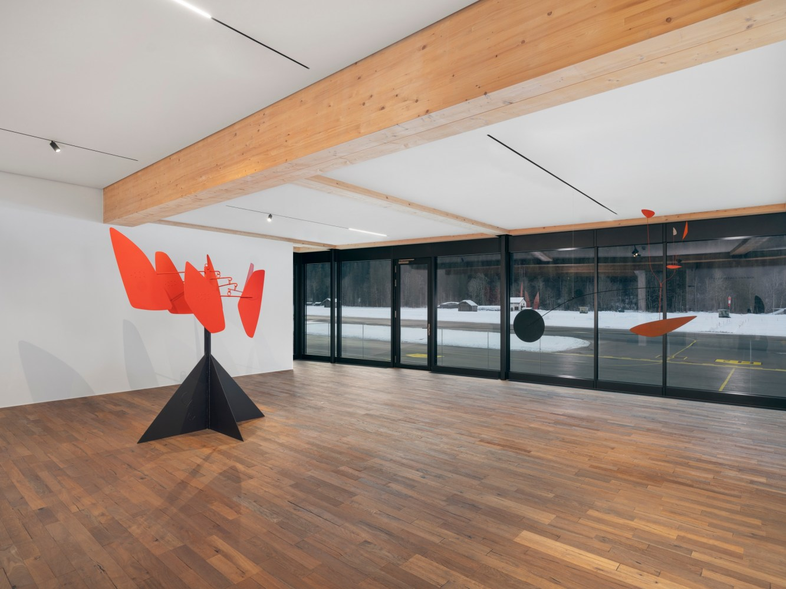

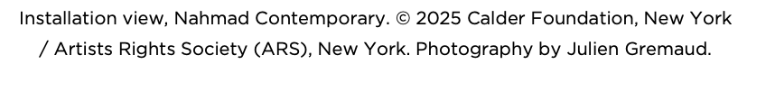

**PRESS RELEASE**

**GSTAAD, SWITZERLAND—Nahmad Contemporary** is pleased to present ***Calder in Flight***, an exhibition at Tarmak22 in the Gstaad airport, on view **February 11 through March 15, 2025**, and featuring the works of venerated American artist **Alexander Calder** (1898–1976). The presentation marks the gallery’s second exhibition dedicated to Calder, whose mobiles transformed twentieth-century art by using the movement of air to animate abstract forms. Spanning five decades, this selection of Calder’s sculptures is enriched by the perspective of one of the leading voices in the creative industry working today, **Edward Enninful**, who will oversee the unique installation in a setting that invites reflection on aerodynamic principles in resonance with the artist’s gravity-defying works.

The works featured in *Calder in Flight*were created throughout Calder’s prolific career between the 1930s, the crucial decade when he conceived and honed his pioneering sculptural language, and 1974, two years before his death. Composed of the artist’s signature painted, industrial sheet metal elements, suspended from wire and rods, the sculptures on view synthesize the evolution and precision of Calder’s aerodynamic forms. They include examples of the artist’s foundational works—such as *Black Disc with Flags*(c. 1939) and *Tic Tac Toe* (1941)—as well as his more complex compositions from his mature period, including *Gouvernails rouges* (1967). The latest work in the group, *Crag with Petals and Yellow Cascade* (1974), elegantly mirrors the interplay of aerial objects amid the exhibition’s mountainous backdrop.

*Calder in Flight* invokes a dynamic dialogue between Calder’s ethereal kinetic works and the world of aviation, both mediated by the artful manipulation of invisible forces. Calder’s mobiles—delicately suspended in the air—were born from the artist’s boundless intuition in their achievement of balance and design. Visiting Calder’s Roxbury studio in the early 1950s, Selden Rodman remarked on its similarity to that of the Wright brothers, “This was no studio such as sculptors had traditionally worked in throughout the ages … The air was busy with dangling ‘contraptions,’ as the brothers in Dayton used to call their experimental warped airfoils and rudimentary engines. But more significantly, I thought, the Wrights too were in love with simplicity, with perfection of motion and economy of means. They began and ended their work *as artists*.”[i]

Calder’s earliest mobile sculptures were realized during the burgeoning golden age of the aviation industry, a period marked by innovations in aerodynamics and the rise of commercial air travel. While in Paris in 1927, the artist was among thousands of spectators who went to Le Bourget to see American aviator Charles Lindbergh land the first solo, transatlantic flight from New York to Paris.[ii] Two decades later, he created *The Blériot*(1949) and *New Blériot* (c. 1950), named after a seminal French aviator and engineer. Through the years, his singular mobiles have graced bustling airport terminals, from his monumental *.125* (1957) in the John F. Kennedy International Airport and *Pittsburgh* (1958) at Pittsburgh International Airport to *Red, Black and Blue* (1968), which formerly hung at Dallas Love Field Airport. Perhaps most notably, Calder was commissioned by Braniff International Airways to design the exterior of Douglas DC-8 and Boeing 727 airplanes in*Flying Colors*(1973) and *Flying Colors of the United States* (1975).

*Calder in Flight*will be accompanied by an illustrated catalogue with text by Enninful. Designed by Studio MDA, the exhibition is presented at the distinct location of Tarmak22, where Calder’s works are set in dialogue with the striking atmosphere alongside the tarmac where aircraft take flight in vivid displays of aerodynamics.

**ABOUT EDWARD ENNINFUL**

Regarded as one of the leading voices in the creative industry today, Edward Enninful, OBE, has helped bring widespread distinction to global fashion. He has spent over thirty years promoting minority and ethnically diverse talent and has strived to eliminate ethnic exclusion in the industry by uplifting and giving regular exposure to underrepresented topics, talent, and models.

Born to a Ghanaian army officer and a seamstress, Enninful became the youngest-ever fashion editor of an international publication,*i-D* magazine, at eighteen. Quickly making his mark within the industry, by 1998, he became a contributing fixture at *Italian Vogue,* catapulting him into world recognition as a leading stylist and cultural contributor. Here, Enninful spearheaded “The Black Issue,” which featured only black women, and which started the necessary dialogue amongst a wider public audience that continues today. He continued to use his voice to make a positive impact in the industry with roles at *American Vogue, W Magazine*, and most recently, *British Vogue*—becoming the only black person to serve as Editor-in-Chief in *Vogue*’s history and successfully transforming the publication into a diverse and inclusive multi-platform brand. Enninful’s dedication to diversity in fashion was honored with the presentation of an OBE.

[i] Selden Rodman, “Alexander Calder,” Conversations with Artists (New York: Devin-Adair), 1957.

[ii] Jed Perl, “Sensibility and Science,” Calder and Abstraction: From Avant-Garde to Iconic, exh. cat. (Los Angeles County Museum of Art, 2013), 49.

Tarmak22  
Oeystrasse 29, 3792 Saanen, Switzerland

Monday - Sunday 11AM - 6PM

For Press Inquiries:  
Capucine Milliot  
capucine@nahmadcontemporary.com

[Download German Press Release](https://www.nahmadcontemporary.com/attachment/en/61ba698f7cc9cc32d60d9a24/TextTwoColumnsWithFile/67814183537ce606e003b4b1)

[Download English Press Release](https://www.nahmadcontemporary.com/attachment/en/61ba698f7cc9cc32d60d9a24/TextTwoColumnsWithFile/67814183537ce606e003b4b1/additionalFiles/678a58d3536bd869af09d8f3/translatedAdditionalFiles/678a58d3536bd869af09d8f4)

[Download French Press Release](https://www.nahmadcontemporary.com/attachment/en/61ba698f7cc9cc32d60d9a24/TextTwoColumnsWithFile/67814183537ce606e003b4b1/additionalFiles/678a58d3536bd869af09d8f3/translatedAdditionalFiles/6792c928c7698cd4f603bf21)